MZUZU DIOCESE CATHOLIC SECONDARY SCHOOLS
2016 MALAWI SCHOOL CERTIFICATE OF EDUCATION MOCK EXAMINATION
MATHEMATICS Subject Number: M131/II
Tuesday, March 22 Time Allowed: 2Hours 30 min
7.30 am – 10.00 am
PAPER II (100 Marks)
Question number | Tick if answered | Do not write in this column
1
2
3
4
5
6
7
8
9
10

11
Total
Instructions
1. This paper contains 18 pages. Please check.
2. Answer all questions in section A and any three
questions from section B.
3. The maximum number of marks for each answer
is indicated against each question.
4. Write your solutions in the spaces provided.
5. Calculators may be used.
6. All working must be clearly shown.
7. Write your NAME and CLASS at the top of
every page.
8. In the table provided on this page, tick against the
question number you have answered.

2016 MZUZU DIOCESE Turn Over
Section A (55 marks)
Answer all the six questions in this section

- a. Simplify to the lowest term $\frac{x-2}{x^{2}-3x+2}$ ÷ $\frac{x}{x-2}$ . (3 marks)

b. Given the function $f(x)$=$\frac{9}{ax+b}$ where a and b are constants, $f$(2) =3 and $f$($-4$)= $-1$, find the values of a and b. . (6 marks)

- a. Make $k$ the subject of the formula$ab=m^{k}$ . (3 marks)

b. In figure 1 below, angle CEB =30$°$, angle AFB =40$°$ . BCF and DCE are straight lines.
A

D
C
B

40º
30º
F
E
Calculate angle BAD. (5 marks)

- a. If A= $\left[\begin{matrix}1 & 0 \\ 3 & -2\end{matrix}\right]$ , B=$\left[\begin{matrix}x & 0 \\ 1 & 3\end{matrix}\right]$, and AB=BA, find $x$.(4marks)

b. 50 students are asked whether they like English, History or Geography. 3 students like none of them, 25 like English, 25 like History and 11 like Geography, 2 like English and history only. 2 like Geography and History. No student like English and Geography only.
(i). Draw a venn diagram to illustrate this information
(ii). Calculate how many students like all the three subjects. (5marks)

- a. Solve the following equation leaving your answer to 2 d. p. $2x^{2}+7x+1=0$ . (5 marks)

b The coordinates of M are (5,-2)and the coordinates of its image M′ are (-2,7). Find
    - $\overset{→}{MM^{'}}$

$\overset{→}{|MM^{'}|}$ (4 marks)

- a . A triangle has an area of 40cm².Two adjacent sides of the triangle are 8cm and 12cm long. Work out the angle between the two sides. . (4 marks)

  - The sum of the first five terms of an AP is $\frac{65}{2}$. Also, five times the 7th term is the same as six times the 2nd term. Find the first term and common difference of the AP. (6 marks)

- a. Given that BOC is a diameter, AD is tangent to the circle and that angle ADC=90º.
O
D
A

E
C
B

Prove that AC bisects angle BCD. (4marks)

b. In a single diagram construct, without using a protractor,
    - a triangle PQR with PR=7cm , PQ=11 and angle PQR=30⁰,
    - through R a perpendicular to QR, produced, if necessary
    - a perpendicular bisector of PR. Let them meet at I
    - a circle which passes through P and R and has PR as the tangent at R.
    - measure and write down the radius of the circle. .
(6 marks)

Section B (45 marks)
Answer any three questions from this section.
- a. . The variance of $a$ and $3a$ is 4. Find the possible values of a. (6 marks)

- If M varies partly as the square of A and partly as the cube of A. When A=20, M =416 and when A=40, M=3264. Find M when A = 30. (9 marks)

- a. Solve the equation :${ 2}^{2x+1}-129\left(2^{x}\right)+64=0$ (7marks)

b. A bag contains 5 red balls and 3 green balls. A ball is selected at random and not replaced. A second ball is then selected. Use a tree diagram to find the probability of selecting one red ball and one green ball. (8marks)

- a. solve the simultaneous equations
$$x-2y=3$$
${ x}^{2}+y^{2}=26$ . (8 marks)

b. A rectangular box with top WXYZ and base ABCD has AB= 6cm, BC=8cm and WA=3 cm.
Y
Z

W
X
D
C

B
A

Calculate: (i). the length of AC (3marks)
(ii). the angle between WC and AC. (7marks)

10. a. Given that$x+2$ and $7x-5$ are factors of $14x^{3}+ax^{2}+bx+10$ , find the value of a and b. (7 marks)

b. A garage stocks two kinds of engine oil. They have $x$cases of regular oil and y cases of super oil.
They have fewer than ten cases of regular oil in stock and
Between three and nine cases of super oil in stock.
They have also fewer than 12 cases in stock altogether.
    - Express the three constraints above as inequalities in addition to $x≥0$ and $y≥0$
    - Using a scale of 2cm to represent 2 units on the horizontal axis and 2cm to represent 2 units on the vertical axis, draw a graph to show the region represented by the in equalities by shading the unwanted region.
    - Using your graph find the maximum number of combined regular and super cases of oil that the garage can stock.
(8 marks)
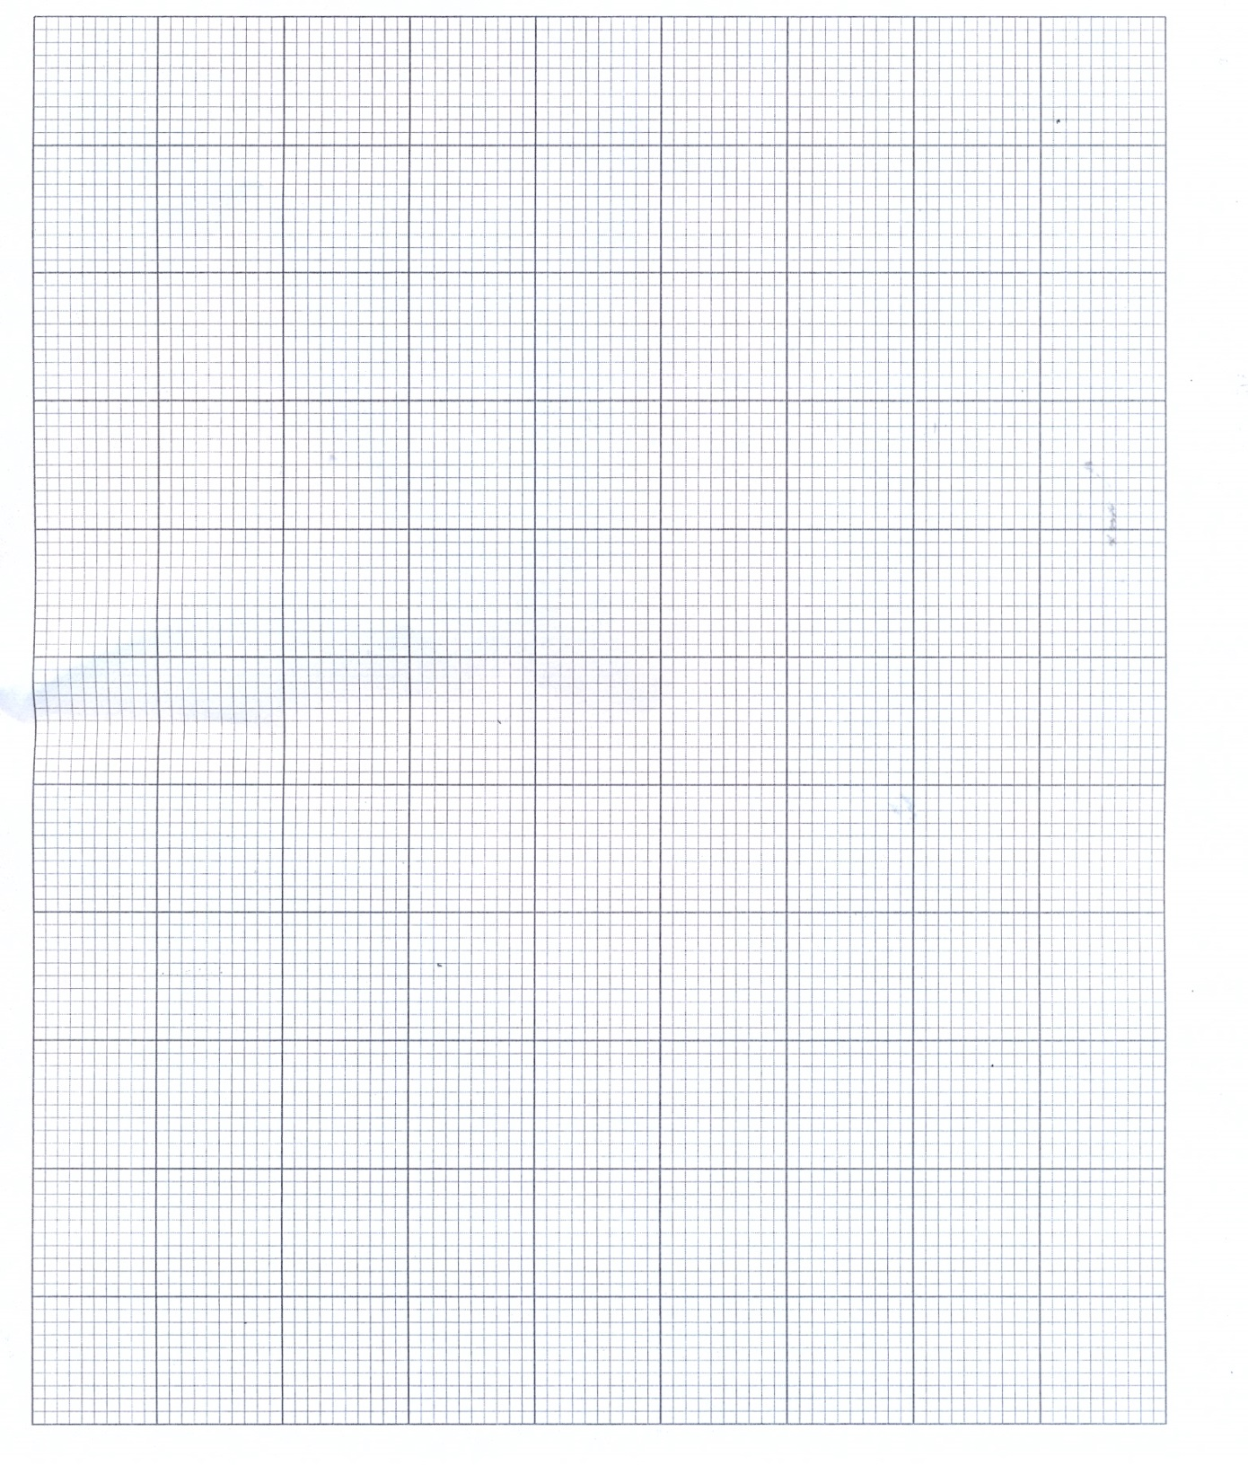

11 a. A ship sails from port A for 35km on a bearing of 120⁰, and then for 54km on a bearing of 250⁰. How far is it from the port now? (6 marks)

b. (i). Complete the table of values for the equation $y=x(x^{2}-4)$

$$x$$ | $-$3 | −2 | −1 | 0 | 1 | 2 | 3
$$y$$ | $-$15 | 0 |  | 0 | −3 |  | 15

(ii). Using a scale of 2 cm to represent 1 unit on the horizontal axis and 2 cm to represent 5 units on the vertical axis, draw the graph of $y=x(x^{2}-4)$.
(iii). Use your graph to solve the equation:${ x}^{3}$ $-7x=6$ (9 marks)

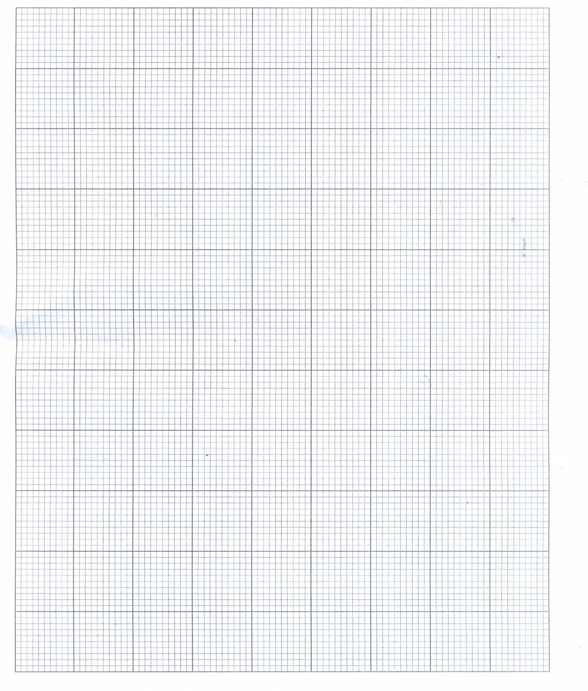
END OF QUESTION PAPER
NB: THIS PAPER CONTAINS 18 PAGES PLEASE CHECK:

